Missio Nexus Workshop: Crossing Cultures – Redeeming Mankind

Session 2: Crossing Cultures in the Old Testament

Old Testament Cultural Overview
- Beginning in Genesis 12, the Old Testament covers a period of nearly 2000 years. Crosscultural encounters over such an extensive period of time were numerous.
- Israel was to function like a magnet, drawing the nations to itself through its fear of the Lord, manifest blessings, and godly living.

Sarah & Hagar: Honor and Shame (Genesis 16 & 21)
- Heartless Sarah
- Honor & Shame
- Sarah’s Conflict
- Recognize that your cultural orientation is primarily guilt/innocence
- Exegete the host culture
- Refocus your gospel presentation to the honor/shame paradigm

Marriage of Jacob: Consequence of Cross-Cultural Ignorance (Genesis 29)
- Understand cultural generations
- Ignorance of the law (customs) is no excuse
- “Cultural exceptions” do not apply

The Israelite Community: Tribes, Clans and Families (Num. 1:1-4, 16-19)
Strata Defining parameters
Family same blood, language, mythology, culture, totem
Clan same language, creation myth, totem, culture
Tribe same ancestry, language & culture
Community same leaders: specialization & surplus wealth
Nation centralized government, geo-political boundaries

Ruth’s Cross-Cultural Conversion (Ruth 1:15-18)
Be determined to leave your home culture behind

Be determined to assimilate into your new culture
Racial identity
Religious identity
Enduring identity
Geographic identity
Become a valued member of the host community

David & Uriah: The Interplay of Power-Distance (2 Samuel 11)
Power – Distance
The word “sent”
Symmetric Parallel
A1. (Bathsheba) “So David sent messengers and took her…” (4)
B1. (Joab) “So David sent word to Joab, ‘Send me Uriah
the Hittite.’” (6)
C1. (Uriah) “And Joab sent Uriah to David” (6)
C2. (Uriah) “…tomorrow I will send you back” (12)
B2. (Joab) “Then Joab sent and told David all the news…” (18)
A2. (Bathsheba) “David sent and brought her to his house, and she
became his wife and bore him a son. (27)

High power-distance: Asian, Eastern European, African & some Latin American countries
Low power-distance: Northern Europe, Great Britain, United States, Australia, New Zealand, & some Latin American countries

Solomon & Queen of Sheba: Cross-Cultural Truth Seeker (1 Kings 10:1-13)
She made a remarkable effort to seek out truth (going).
She seriously enjoined the learning process (engaging).
She witnessed firsthand the benefits of applied wisdom and truth (observing/absorbing)
She responded with wonder at what she experienced (responding).
She recognized that God was the ultimate source of all that she witnessed (acknowledging)
She expressed gratitude to Solomon (appreciating)
She went home a different person (returning)

Home


Cross-cultural Seeker Cycle

Nehemiah: Leading a “Despised” Cultural Minority (Book of Nehemiah)

- Opposition by intimidation
- Opposition by ridicule
- Opposition by threat of armed conflict
- Opposition by intrigue
- Opposition by smear campaign
- Opposition by character assassination
- Opposition by stealth

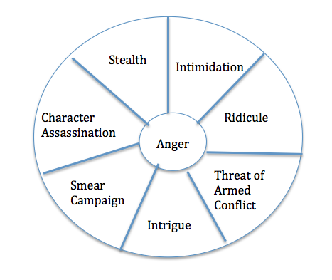

Neutralize
Opponents

Appropriate responses

Indomitable
Courage
Will to Confront

Confidence: in self, by others, by God in you

Firm belief in God’s sovereignty
“the good hand of God”

Marv Newell
Missio Nexus, Feb. 2017

